**Project Pre-Proposal**

**Project Title:** “Trained Deep Learning Model + Artifacts as a Service”

**Team Number:** 1 / Tiancheng Xie (Class ID: 25); Chen Sun (Class ID: 23); Corey Doss (Class ID: 8); Khalid Mohammed A Dhabbah (Class ID: 6)

**Project Goal and Objectives:** Our aim is to build a platform online that can utilize the Machine Learning (ML) and Deep Learning (DL) model(s). The platform will offer users the opportunity to upload their own datasets and specify their own requirements. It will assist users by suggesting a suitable model to generate the desired results.

**(Bonus/Stretch Goal**: Gather user feedback and use that feedback to further optimize the model! (This will be a very rewarding challenge to strive for.)**)**

* **Motivation:**
  + It can be difficult to introduce ML & DL model(s) to professionals who have full-fledged/comprehensive datasets, but have no knowledge or training in Computer Science. We hope to create a path for those without programming knowledge to further utilize their data.
  + To have further opportunity to use and experiment with predictive modeling.
  + We will perform a survey at the earliest opportunity to explore this novel software approach.
* **Significance:** 
  + So far, we are still experimenting with our model. Our goal is to use deployed servers that can score user input requirements, dependent upon on our model, without training and generate new predictions. Now we need to collect some relevant data and prepare for the experiment; this will change our experiment into a prediction experiment.
  + We will use **lexical keywords** to search for the best model, in terms of picking the one that has the best accuracy. For example, if a user chooses to type “sement”, it will return a ranked list of models in the searching bar.
  + In order to enhance the user interface and promote a lower learning curve for our application, we will plan on utilizing Asynchronous JavaScript and XML (AJAX) and Angular features in our design process.
* **Scope:**
  + At minimum, our software will (1) allow users to provide datasets that will then be used for predictive modeling, and (2) allow predictions to be returned to the user without any requiring any time investment in training the software first.
* **Blueprint:** This is a three-step process:
  1. Prepare the layout of the multi-responsive website
  2. Deploy the model on it, and point to a specific area.
  3. User functionality focus in JavaScript files.
* **Workflow(using ZenHub Tool):** Use ZenHub create milestone for every increment. (figure 1)
  + **Project plan:**
    - Prioritized Features/Technologies
    - Schedule for the FOUR increments (for each increment, do the following tasks)
      1. Stories (Issues): Scenario & Use case specification
      2. Service Design (detailed service design, test design)
      3. Service Implementation (implementation and testing)
    - Project Timelines, Members, Task Responsibility
    - Burndown Chart (figure 2)
  + **Increment 1: Create the Main page of the application.**
    - Nav bar:
      1. Take consideration of Multi-level drop-down menu design
      2. Search Bar
      3. Other pages for linking
    - Body: Suitable blocks and layout with CSS.
    - Footer
  + **Increment 2: Model development**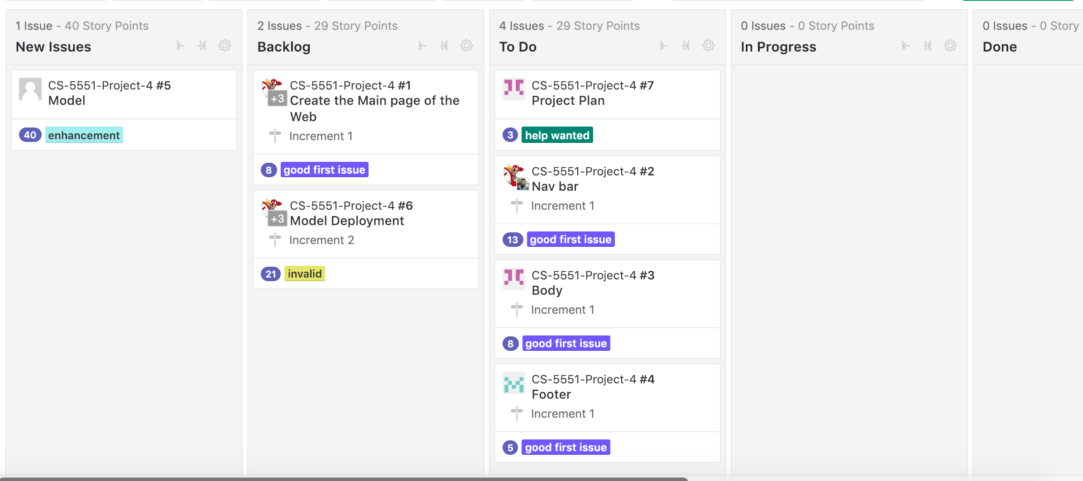

figure 1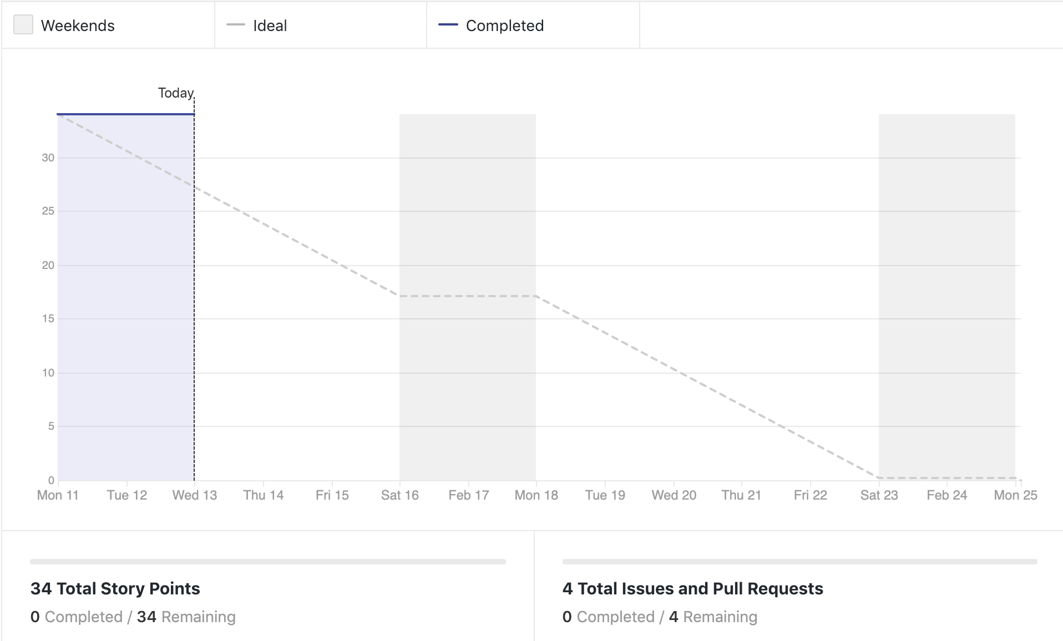

figure 2

* **Potential Toolsets / API’s Being Considered:**
  + Support Vector Machine (SVM) (ML), Convolutional Neural Network (CNN) (DL), Flask (Deployment Tool), misc. front-end interface
  + Python-embedded web application

**Related Work / Citations:**

“Cloud AutoML - Custom Machine Learning Models  |  AutoML  |  Google Cloud.” *Google*, Google, 17 Jan. 2018, cloud.google.com/automl/.

Ericson, Gary, et al. “Step 5: Deploy Web Service - Azure Machine Learning Studio.” *Microsoft Docs*, 22 Mar. 2017, docs.microsoft.com/en-us/azure/machine-learning/studio/walkthrough-5-publish-web-service.

hjc1984117 . “What Is a RESTful API?” *What Is a RESTful API?*, 17 Aug. 2017, blog.csdn.net/hjc1984117/article/details/77334616.

Konrad, Yad. “What Is the Easiest Way to Deploy a Machine Learning Model (Say a Regression) for Production?” *Quora*, Quora, 29 Feb. 2016, www.quora.com/What-is-the-easiest-way-to-deploy-a-machine-learning-model-say-a-regression-for-production.

Nalinda, Chamin. “Embedding Machine Learning Models to Web Apps (Part-1).” *Towards Data Science*, Towards Data Science, 10 June 2018, towardsdatascience.com/embedding-machine-learning-models-to-web-apps-part-1-6ab7b55ee428.

Sionek, André. “Simple Deployment of Web App + ML Model + APIs - Tutorial.” *Towards Data Science*, Towards Data Science, 4 Dec. 2018, towardsdatascience.com/simple-deployment-of-web-app-ml-model-apis-tutorial-2ece8e66d98c.